Name: Muhammad Adeel
Course: AI Product Manager
Cohort 31
AI Product Management – portfolio assignment
Step 1:
Selecting Google Forms as the Trigger App and setting the Trigger Event to 'New Form Response' in Zapier."
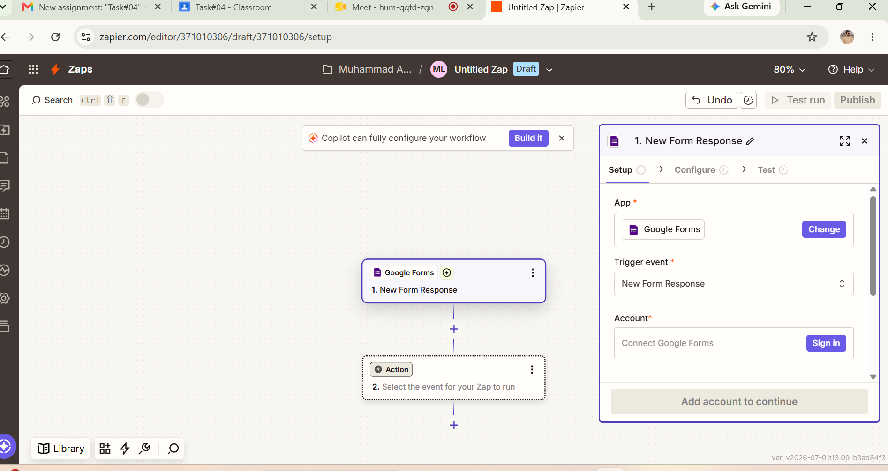

Step 2:
Selecting Google Forms as the Trigger App and setting the Trigger Event to 'New Form Response' in Zapier."

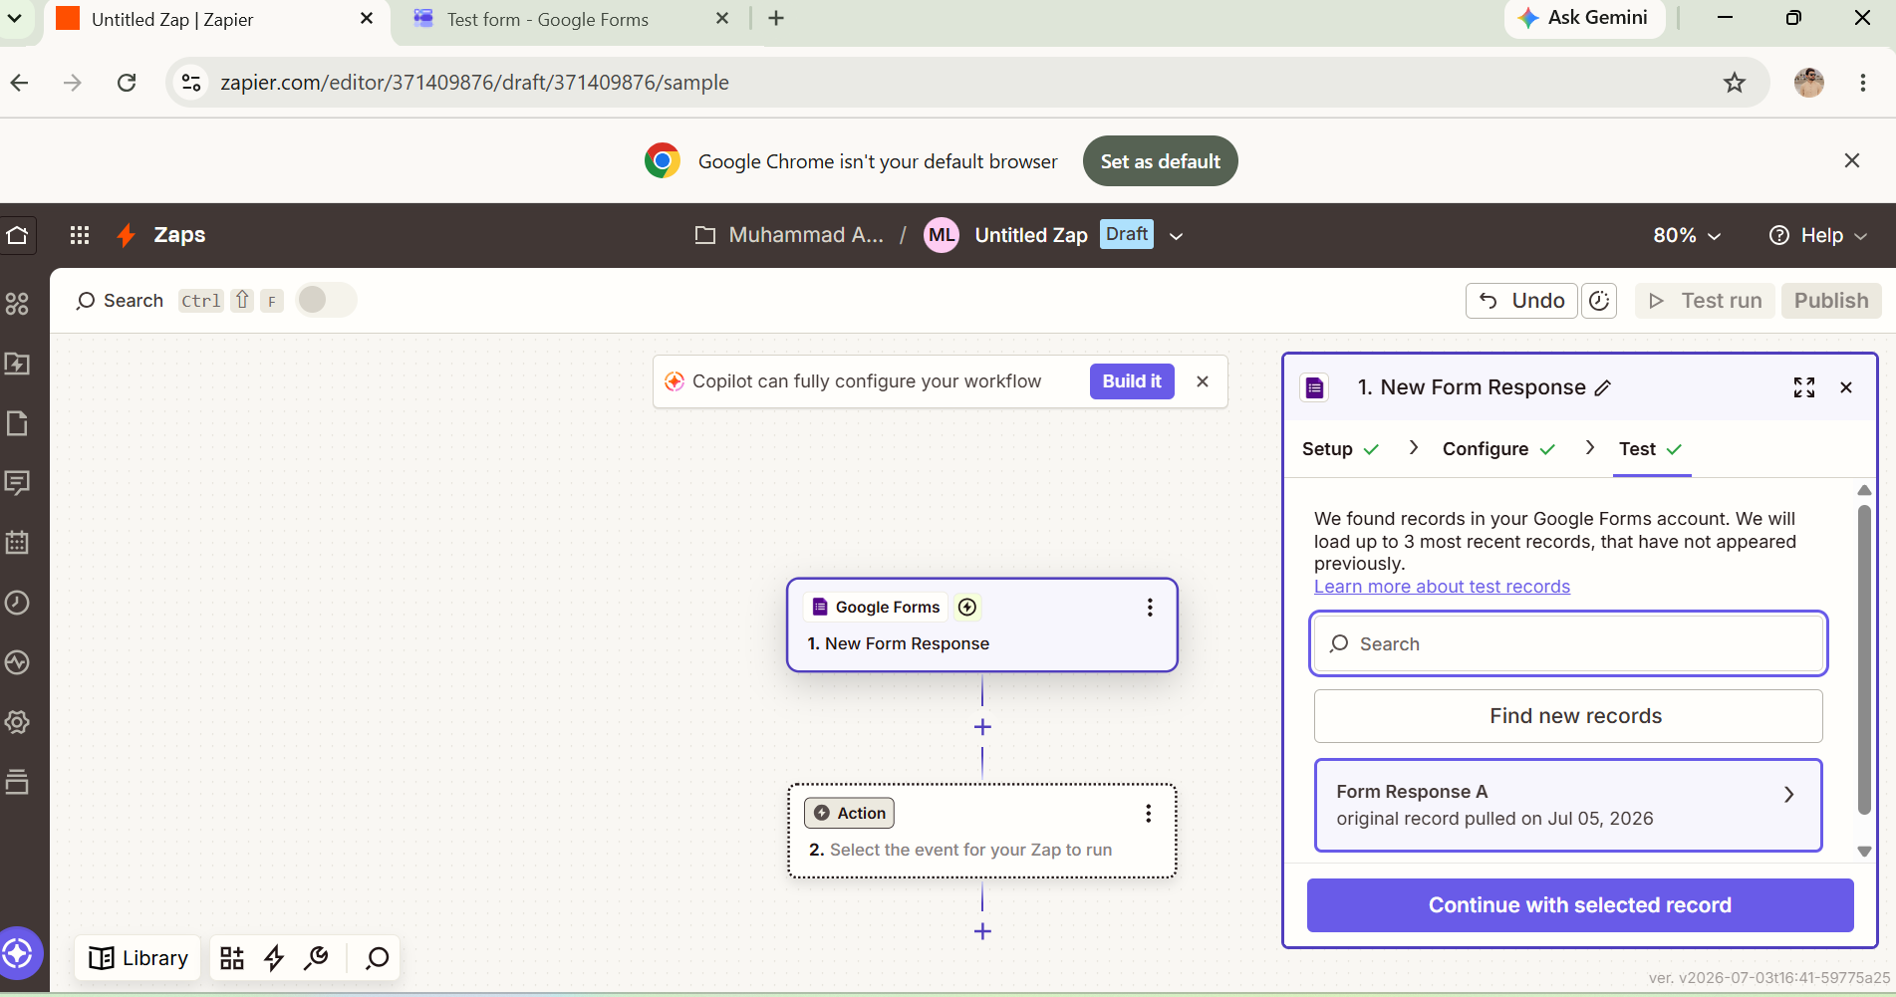

Step 3:
Creating the destination Google Sheet with 'Name' and 'Email' columns to receive the automated data."
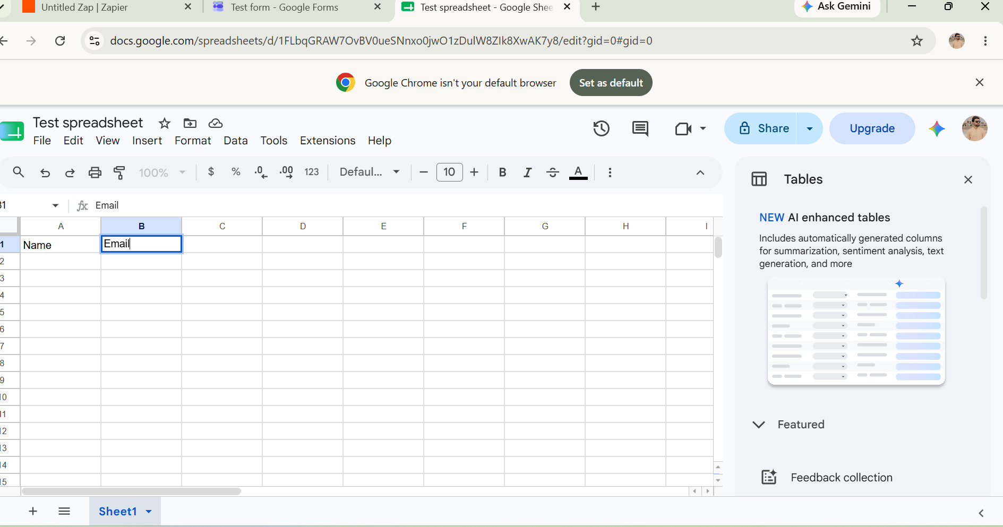

Step 4:
Setting up Google Sheets as the Action App and preparing to perform a test run to create a spreadsheet row."
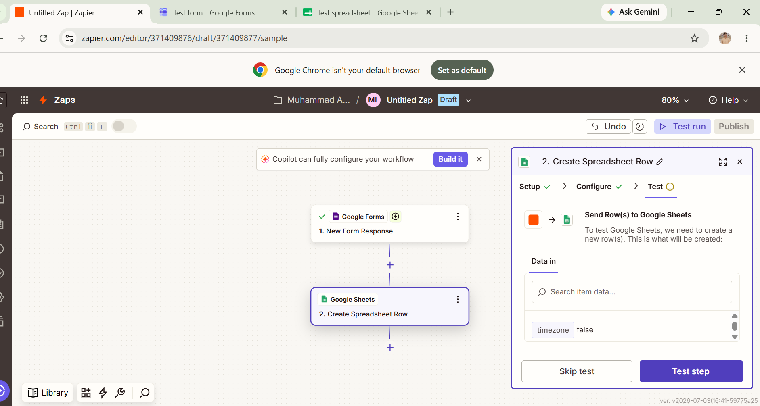

Step 5:
Successfully testing the Action step, confirming data transfer to Google Sheets, and preparing to publish the Zap live."

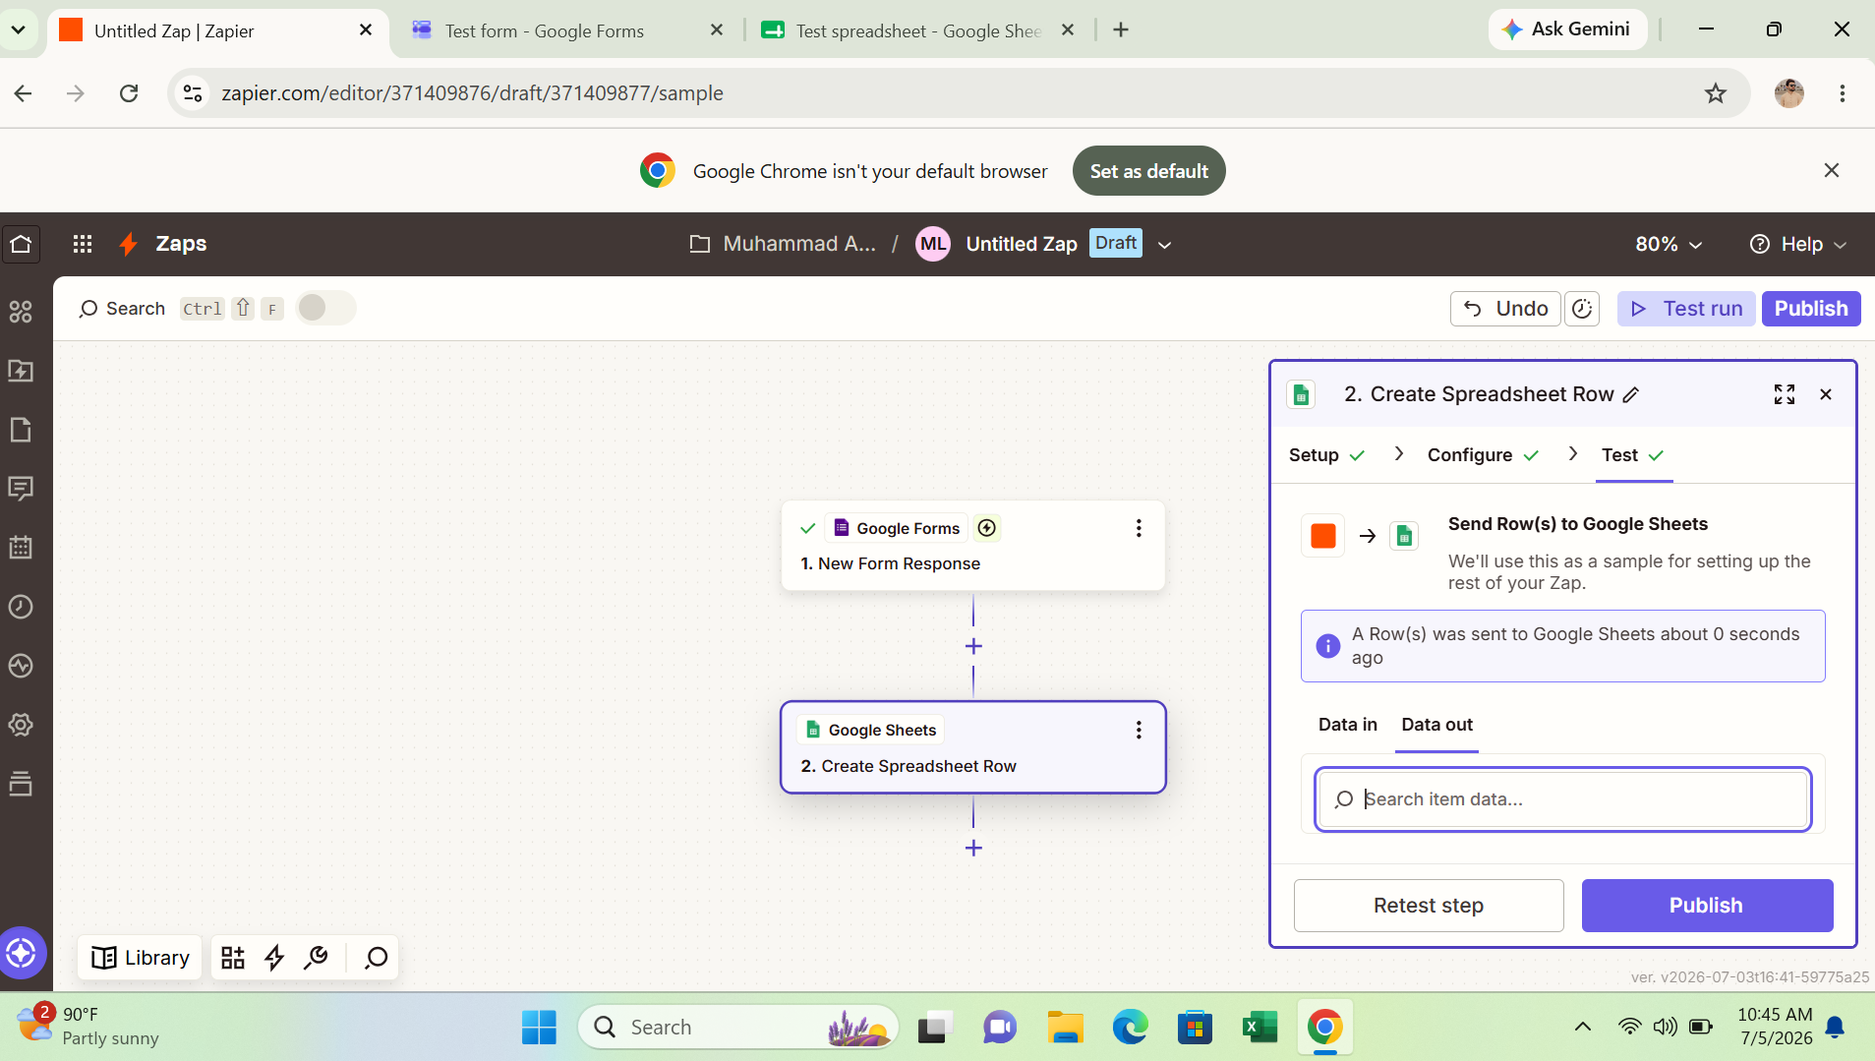

"Step 6:
Final confirmation showing that the Zap is successfully published, active, and running live using version v1."

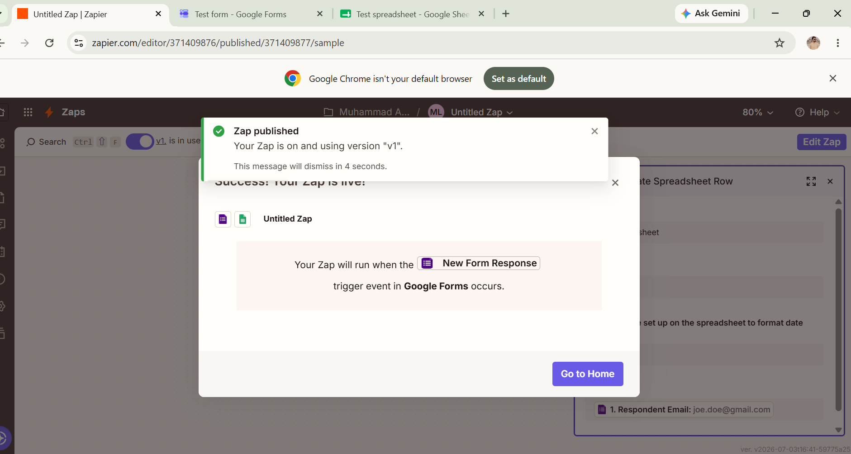

Step 7:
Final verification showing the test data (e.g., joe.doe@gmail.com) successfully transferred to the Google Sheet, confirming the automation works perfectly

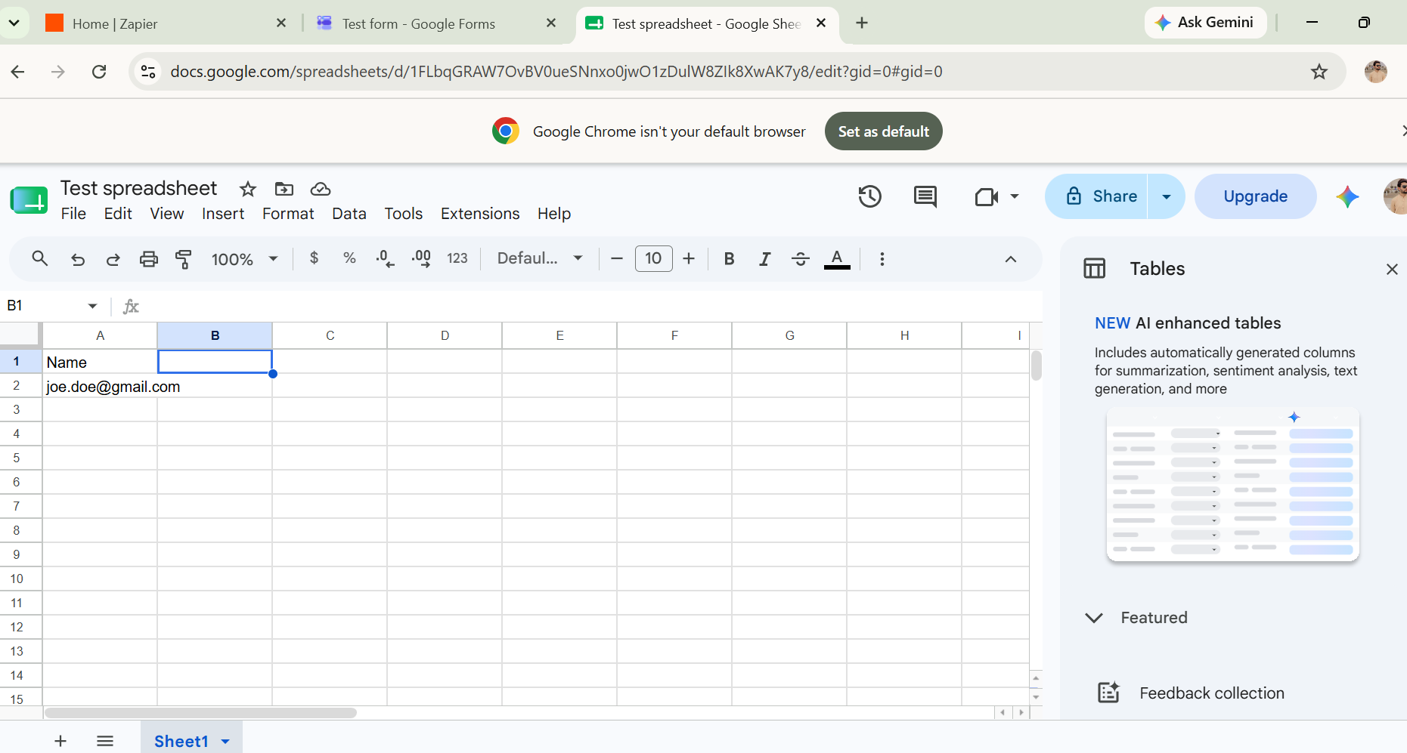

Step 8:
Zapier Automation Workflow Setup

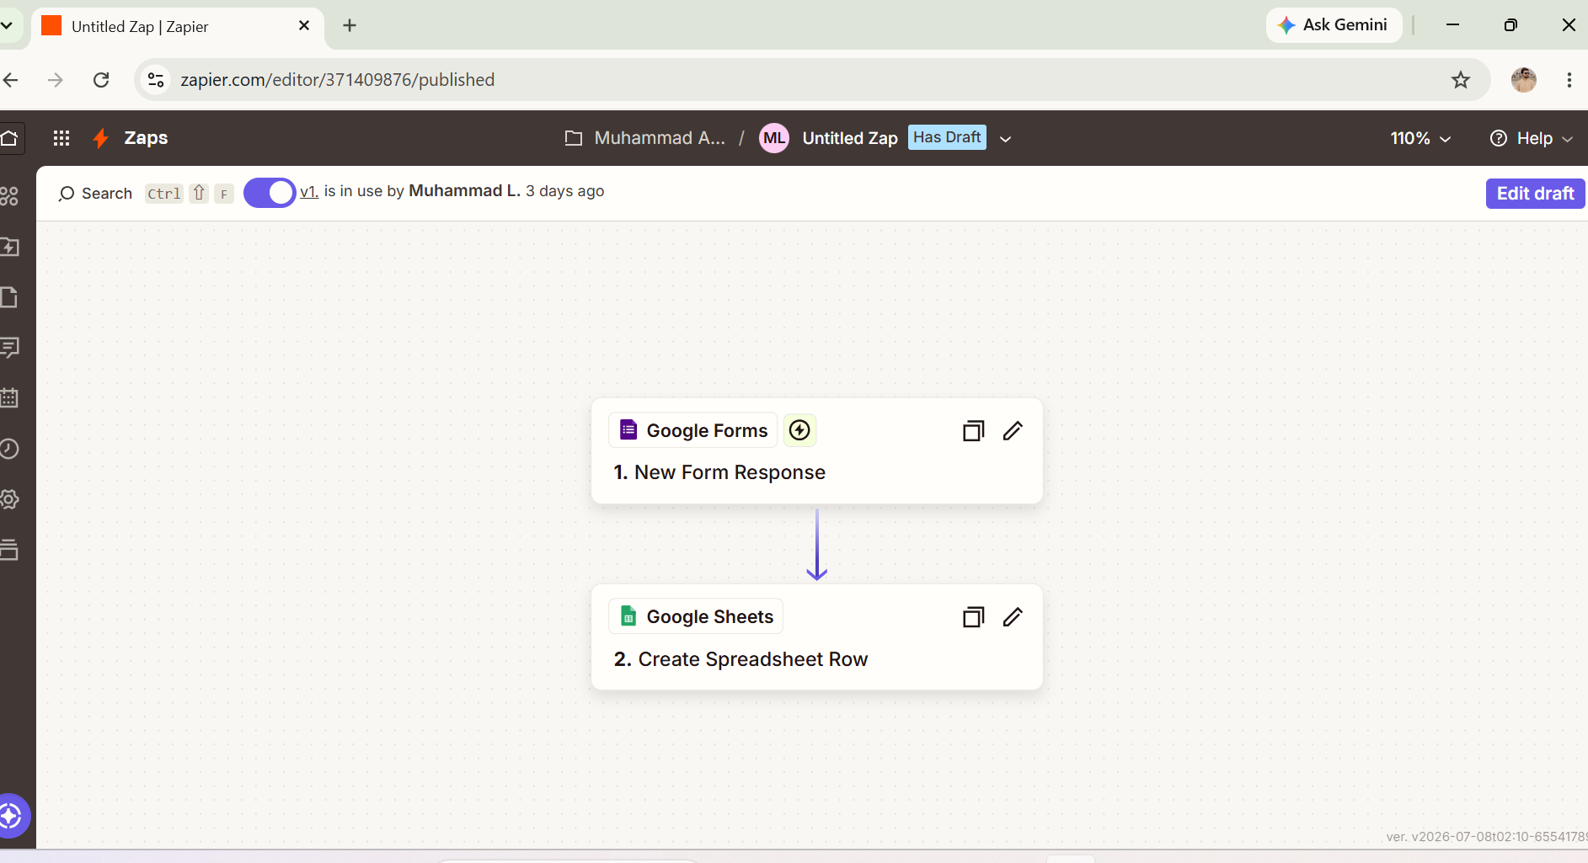

Step 9:
Connected Source Trigger (Google Form)

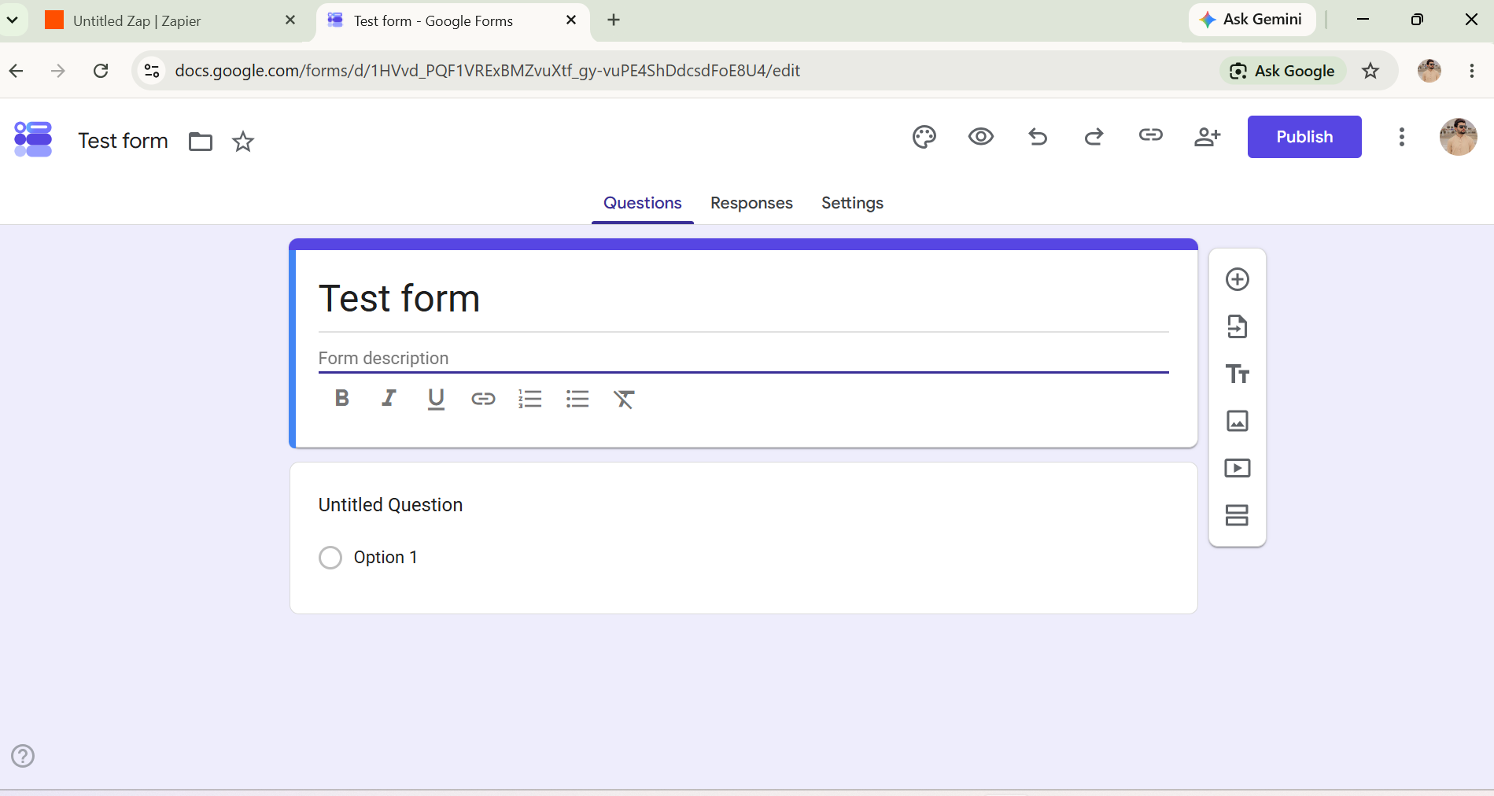
Automated Workflow Diagram (Miro):
This flowchart represents the end-to-end automated pipeline created for our product. It visually maps the structural journey from the instant a user interacts with the trigger application to the final automated row generation in the database.

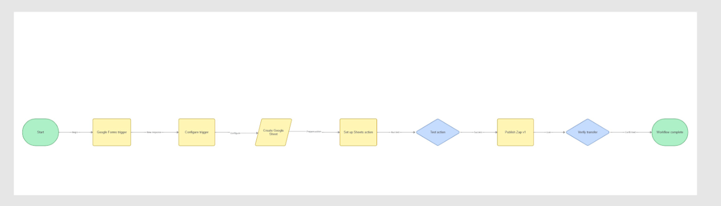
Strategic Product Board & Customer Journey Framework:
This segment maps the strategic alignment of our product using the 4 stages of the Customer Journey (Awareness, Consideration, Decision, and Customer Loyalty). It defines our target user persona, specifies market gaps, and outlines automated retention mechanisms to keep user churn minimal.

